Product Management Launchpad -Case Study
Capstone Project
Truly Madly ™ café
Lakshit jain Co-Hort -28


Truly Madly TM Café - From Dating Feature to India's Loneliness Economy Marketplace
STEP 1-TM Café – Market & User Research
Problem Statement
TM Café is under-discovered and poorly integrated into the user journey, failing to capture users at high-intent emotional moments (e.g., rejection, breakup), leading to low activation and monetization despite strong demand for emotional support.

STEP - 1 MARKET & USER RESEARCH
Research Objective
The goal of this research is to understand:
- Who pays for emotional support and dating advice in India
- Why users choose paid platforms over friends
- When users are most likely to seek help (trigger moments)
- What would make TM Café their first choice

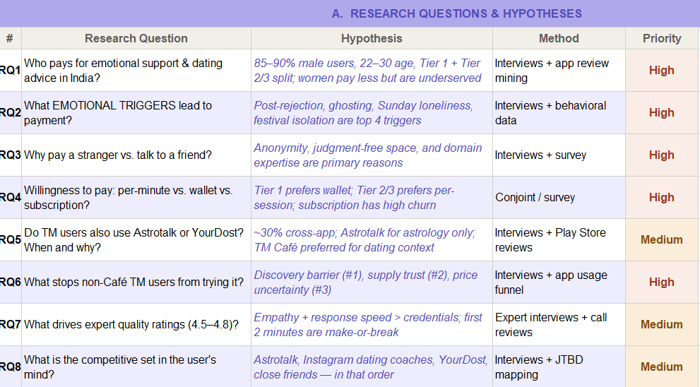
Supporting Data: Full user interview spreadsheet =
https://docs.google.com/spreadsheets/d/10ifRMIynb2KwhFhPBP9evic7QEYNwKZzIM5KZb_TFTg/edit?usp=sharing
Research Methods
Method | What I Did | Type | Output
Personal app testing | Downloaded TrulyMadly and uploaded a fake female photo to test the 90% verification claim it was accepted without any check | Primary | Verification gap confirmed fake profile accepted
Play Store review analysis | Read and screenshotted multiple pages of TrulyMadly and Astrotalk reviews (Feb–Apr 2026) identified recurring pain patterns | Secondary | 4 pain patterns — fake profiles, unauthorized charges, layered paywalls, notification spam
Google Form survey | Created and distributed a survey to understand user emotions, trigger moments, and willingness to pay across dating app users | Primary | Quantitative data on trigger moments and pricing preferences
User interviews | Spoke to friends (age 22–26, Bengaluru) about dating app experiences and Astrotalk payment behaviour | Primary | Validated freemium conversion model — friends paid Astrotalk after 2 mins free
Competitive benchmarking | Used Astrotalk and YourDost apps, compared UI, pricing, conversion model, trust signals vs TrulyMadly | Secondary | Astrotalk freemium model identified as the benchmark
In-app analysis | Navigated TrulyMadly app to find TM Café tab counted clicks, tested payment flow, tested UX | Primary | Café buried 3 to 4 clicks deep, no moment-match nudge exists today

Research Questions and Findings

RQ1 — Why do users call TrulyMadly a scam?
TrulyMadly markets itself with a 90% profile verification promise. In practice, verification is weak fake profiles get through, unauthorized charges appear on bank statements, and the app uses a layered paywall model where users keep paying for features they thought were included. Play Store reviews from early 2026 show this consistently.

RQ1Hypothesis: Fake profiles pass verification because TrulyMadly relies only on phone number verification, not face or document matching

"Scam, Fraud, Money hungry are the right words for this platform. They charged my bank account ₹600 without my permission. I have been arguing with customer care for 10 days."
— Play Store review, Feb 2026 — 2 people found this helpful

"I tried the subscription but all I see is fake profiles."
— Play Store review, Apr 18, 2026

"Even if you buy their top subscription, swipes are still limited to 10–15. For messages you pay separately. For Spark you pay separately."
— Play Store review — 263 people found this helpful
The 263 helpful votes on that last review is significant. This is not one frustrated user — it is a widely shared experience. Layered paywalls, fake profiles, and surprise charges together produce one user feeling: that TrulyMadly is designed to extract money, not deliver value. This directly hurts TM Café, which users will judge through the same lens

Primary Research — App Testing

As part of the research, TrulyMadly was tested directly on the web platform on April 25, 2026. A profile was created using a fake female photo sourced from the internet. The photo was uploaded and the profile was accepted without any verification check, flag, or rejection.
This is significant because TrulyMadly's core brand promise is 90% profile verification. In practice, the verification system failed to detect an obviously fake profile. This means real users on the platform are being matched with fake accounts and paying ₹799 or more for a subscription that does not deliver what it promises.
This single test explains why Play Store reviews consistently use words like scam and fraud. The trust problem is not perception it is a product failure.

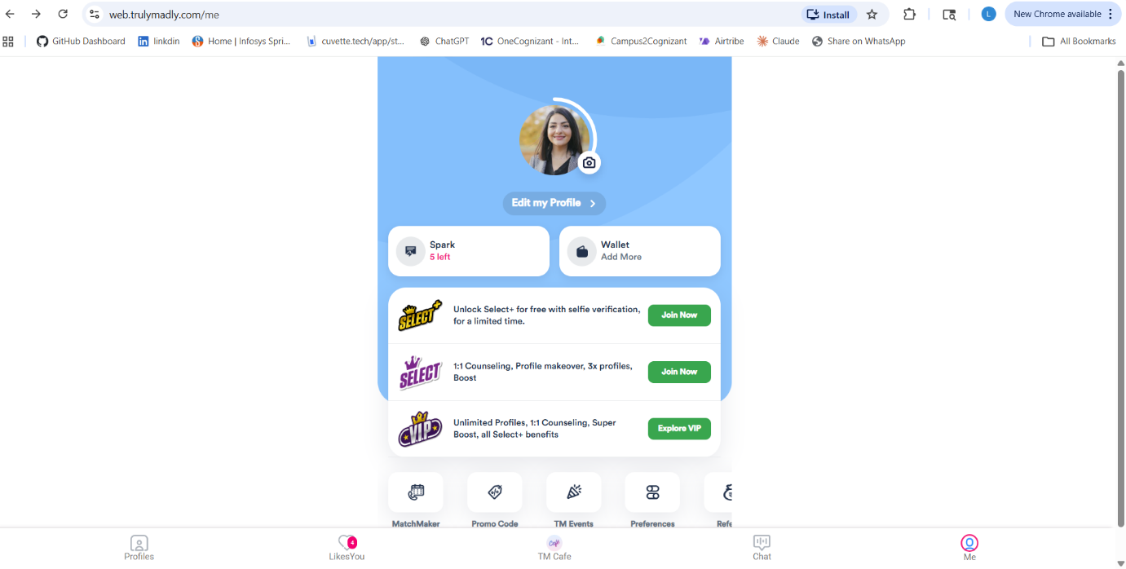
Research Evidence — App Testing and Review Analysis

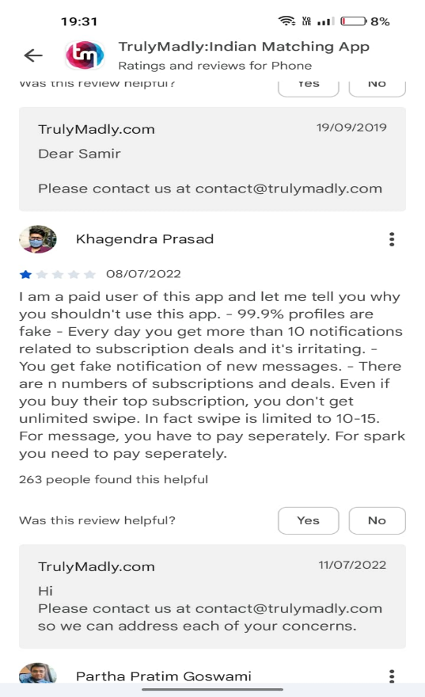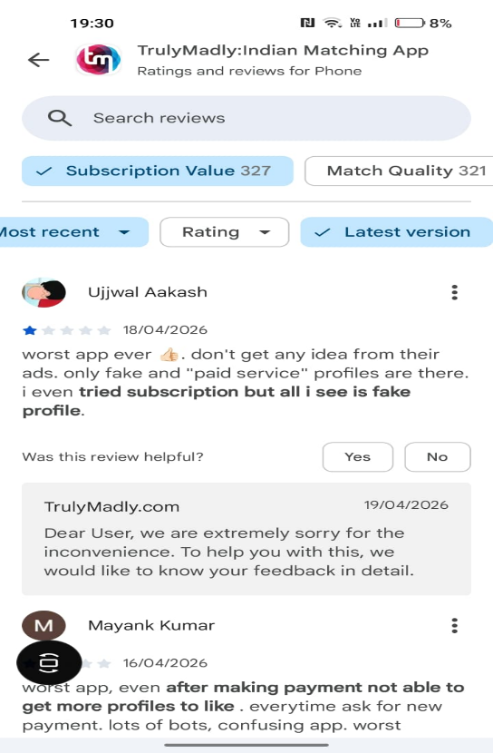
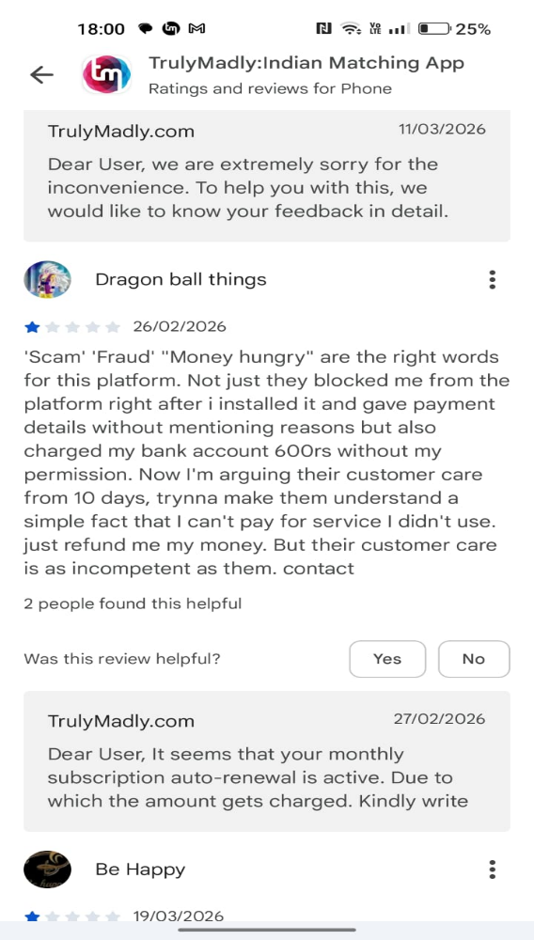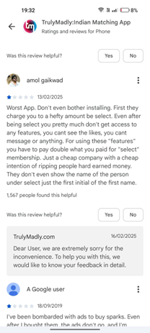

RQ2 — Why does Astrotalk convert but TrulyMadly does not?
Every friend interviewed has paid Astrotalk. None felt cheated. The reason is consistent: Astrotalk gives 2 minutes free first. Users feel real value in those 2 minutes, and then paying feels like a natural next step not a risk.

RQ2 Hypothesis: Users do not refuse to pay for emotional support — they refuse to pay before feeling value. Astrotalk's 2-minute free trial removes the risk of payment and allows users to experience real value first. TrulyMadly's upfront paywall does the opposite. If TM Café adopts the same freemium model as Astrotalk, first-time conversion will increase significantly.

"Astrotalk gave me 2 minutes free. I felt the value in those 2 minutes. After that, paying ₹500 felt completely normal."
— User interview, 24 years, Bengaluru

"All my friends use Astrotalk after the free chat. We share it with each other because the value is immediate."
— User interview, 26 years, Bengaluru

TrulyMadly does the opposite — users pay ₹799 before experiencing anything. When what they receive is fake profiles or broken features, the feeling is not disappointment. It is betrayal.
 | TrulyMadly today | Astrotalk | What TM Café should do
Entry model | ₹799 upfront paywall | 2 minutes free first | 2 minutes free with every expert
User feeling at entry | Risk and anxiety | Low commitment, curious | Remove the risk entirely
After payment | Fake profiles, no value | Real conversation, real answer | Expert warmth in first 60 seconds
Repeat rate | Under 2% of MAU | 25–30% return | Target: 40%+ return in 14 days

RQ3 — When exactly would a user open TM Café?
Consider this scenario: a 25-year-old guy gets ghosted after a week of chatting on TrulyMadly. It is 11pm. He is embarrassed to call his friends. What does he do?

RQ3 Hypothesis: The window between an emotional trigger rejection, ghosting, loneliness and a user leaving the app is approximately 10 to 15 minutes. If TM Café surfaces a moment-matched nudge inside the app at that exact moment with a free trial offer, a significant portion of users will engage rather than exit. Missing this window means the opportunity is lost entirely
Most likely - he closes the app and opens Instagram. He does not look for the Café tab. He probably does not even know it exists. The window where TM Café could have helped him is about 10–15 minutes wide.
But if a message appeared right then 'Feeling low? Talk to someone, first 2 minutes free' most users would tap it. That single screen, at that exact moment, is the core of the TM Café opportunity.

Trigger moment | How the user feels | Without TM Café | With a moment-match nudge
Ghosted after a week of chatting | Confused, embarrassed, alone | Closes app, opens Instagram | Taps nudge, lands on Café home
5 failed swipes in one sitting | Self-doubt, frustration | Keeps swiping or quits | Bottom sheet: 'Feeling low? Talk to someone'
11pm Sunday, no matches this week | Lonely, empty | Watches reels, goes to sleep | Push: 'Talk to someone tonight — first 2 mins free'
Bad date, no second date planned | Disappointed, overthinking | Vents to a friend | 'How did your date go?' prompt in the app

User personas
The research identified four distinct user personas based on emotional state at the moment of need. These personas are not defined by age or city they are defined by what the user just experienced and how they feel in that moment. The same 25-year-old in Mumbai can be a Pre-Date Prepper on Thursday and a Ghosted Overthinker on Saturday. What changes is the trigger, not the person. Understanding these emotional states is what allows TM Café to show up at the right moment with the right expert.
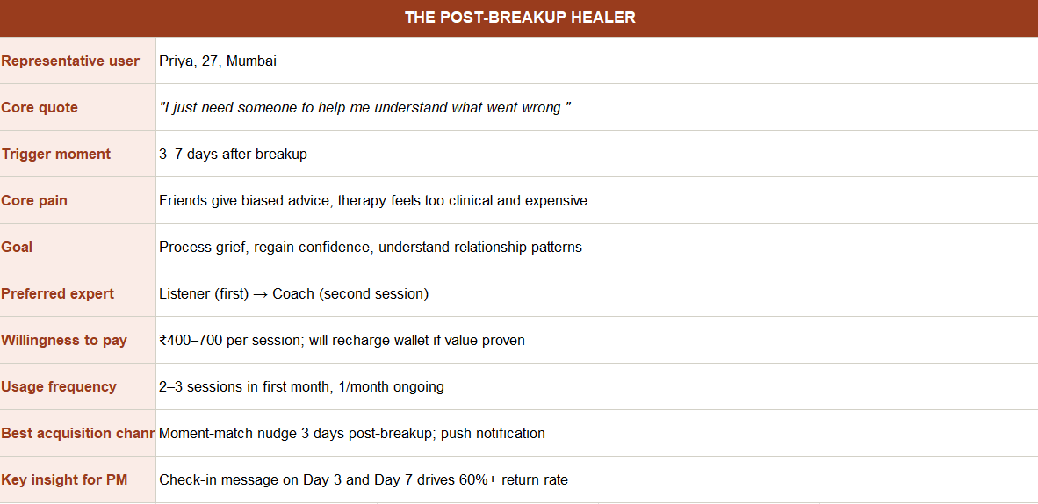

The Relationship Overthinker
This user is 25 to 32 years old and over-analyses everything. One unread message sends them into a spiral. They create scenarios in their head, rehearse conversations, and cannot move on without closure. They are already in a pattern of seeking reassurance — from friends, from Reddit, from anywhere. TM Café gives them something better — a real expert who can give an objective perspective without judgment. They are the highest revenue persona because they come back 3 to 5 times a month. They will pay ₹300 to ₹500 per session and are the most likely to upgrade to a subscription once they have had 2 good sessions. Target them with a post-unmatch nudge and a stalled conversation prompt.
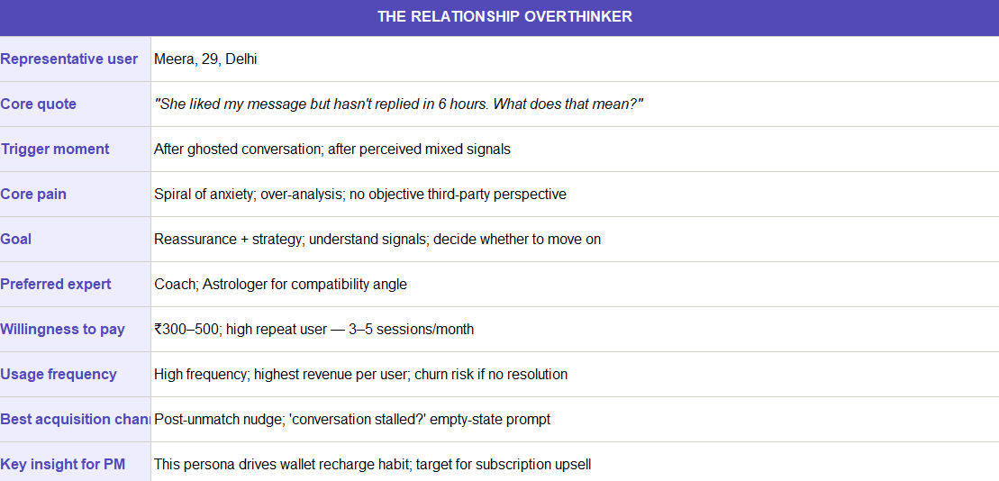
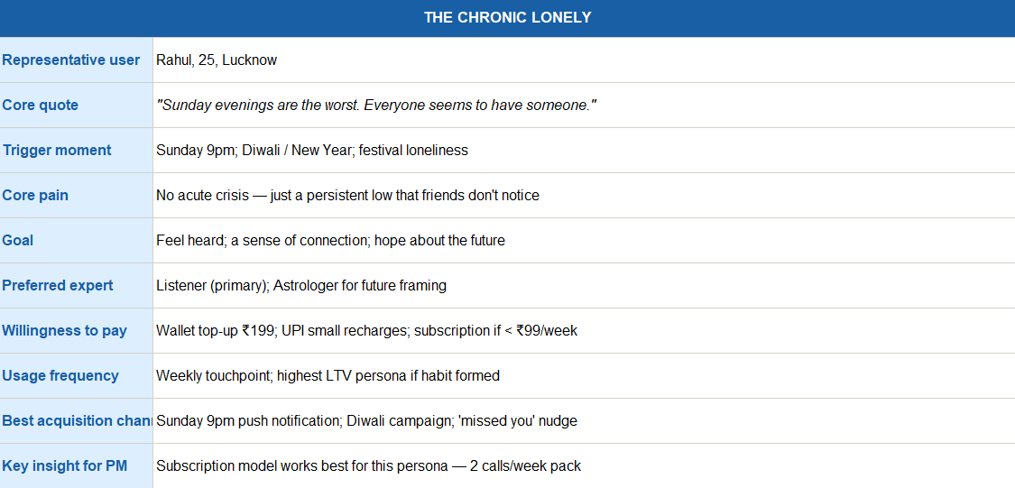

The Chronic Lonely
The Chronic Lonely user experiences a persistent, low-intensity emotional gap, especially during moments like Sunday evenings or festivals, where loneliness feels amplified. They are not in crisis but seek consistent emotional connection and reassurance over time. This segment shows high long-term value potential, making them ideal

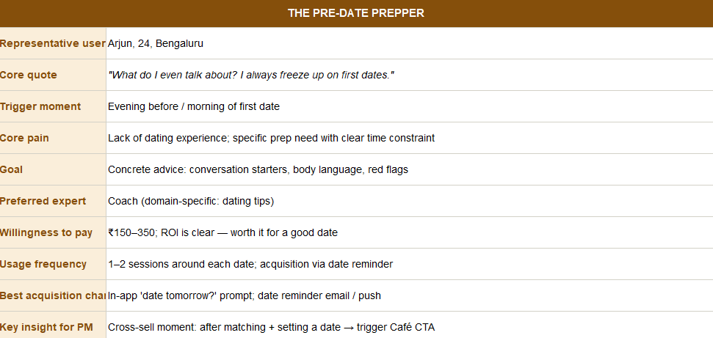
The Pre-Date Prepper
This user has a first date coming up and is nervous. They have not been on many dates and do not know what to say, how to act, or what to watch out for. Their need is specific and time-bound — they want practical advice before the date, not emotional support after it. They are willing to pay ₹200 to ₹350 because the return on investment feels clear — a good date is worth it. The best time to reach them is right after they set a date with a match inside the app. A Coach with a dating tips specialisation is the right expert for them. This persona is the easiest to A/B test and the quickest win for cross-sell from the dating funnel.

Competitive analysis
The research points to one central problem: TM Café has the right idea but the wrong foundation. It sits inside a platform that users do not trust, it is nearly impossible to discover, and it asks for money before giving any value.
Users are not avoiding TM Café because they do not need emotional support. They are avoiding it because TrulyMadly has already let them down. Fake profiles, surprise charges, and layered paywalls have trained users to distrust every payment screen on the app. TM Café inherits that distrust by default.
The comparison with Astrotalk makes this very clear. Astrotalk has 1.5 million paying users not because astrology is more valuable than relationship coaching but because it gives 2 minutes free before asking for anything. Users feel something real, and then they pay. TrulyMadly does the opposite.
The other critical finding is timing. When a user gets rejected or ghosted, there is a window of about 10 to 15 minutes where they are emotionally open and looking for something. After that they move on. TM Café currently does nothing in that window. No nudge, no prompt, no sign that help is available. That is the biggest missed opportunity in the product today.

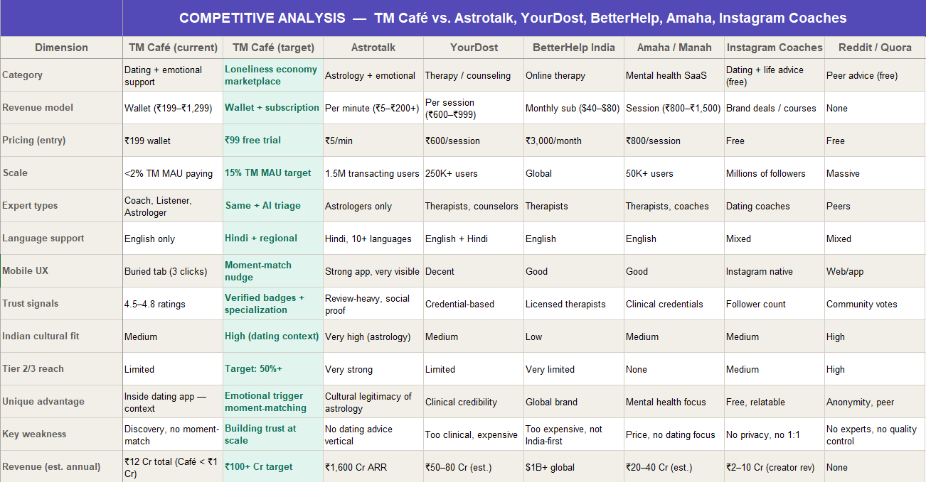
Trigger -To payment funnel
GGER-TO-PAYMENT to Paid Café Cal
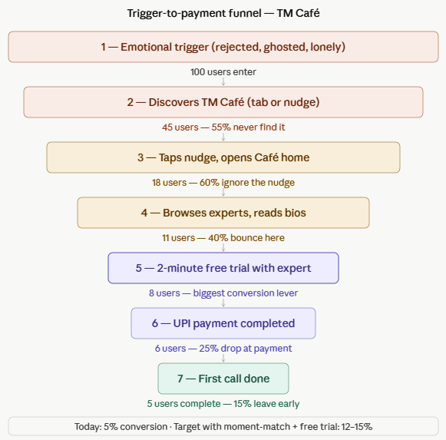

Out of every 100 users who experience an emotional trigger like rejection or ghosting, only 5 end up making a paid call on TM Café today. The two biggest drop-offs happen at discovery because the Café tab is buried and at payment because there is no free trial to build trust first. If we fix just these two things a moment-match nudge after rejection and a 2-minute free trial like Astro talk we can push that conversion from 5% to 12–15%. That is the entire strategy in one funnel
Willingness-to-Pay Research
Pricing Elasticity & Wallet Behaviour
Users in India do not refuse to pay for emotional support. They refuse to pay before feeling value. The research shows that pricing model matters more than pricing amount. A user who happily pays ₹500 on Astrotalk will refuse to pay ₹199 on TrulyMadly — not because of the price but because of the trust gap.
Pricing Model Preference by Tier
Pricing Model | Tier 1 Preference | Tier 2/3 Preference | Key Insight | TM Café Recommendation
Per-minute (₹5–₹50/min) | Low — feels like a taxi meter | Medium — familiar from Astrotalk | Creates anxiety about cost creep | Offer as option, not default
Flat session (₹199–₹500) | High — predictable spend | High — clear value exchange | Most preferred across both tiers | Make this the default model
Wallet top-up (₹199–₹1,299) | Medium — convenient for repeat users | Medium — UPI makes it easy | Works after habit is formed, not before | Secondary model for return users
Subscription (2 calls/week) | Medium — needs proven value first | Low — commitment aversion | Works only after second session | Upsell after second call, not at entry
First 2 minutes free | Very high — removes trial barrier | Very high — biggest conversion lever | Single biggest driver of first payment | Non-negotiable for all experts

Price Sensitivity by User Segment
Key Takeaway
The price is not the problem. The sequence is. Value must come before payment. Once a user has felt something real in a free 2-minute trial, they will pay and they will come back.

Segment |  | Max Willingness to Pay | Sweet Spot Price | Walk-Away Price | Key Note
Ghosted Overthinker |  | ₹600 | ₹300–400 | Above ₹700 | High urgency drives higher WTP
Chronic Lonely |  | ₹400 | ₹199–299 | Above ₹500 | Needs to feel cheap — habit over urgency
Pre-Date Prepper |  | ₹400 | ₹200–350 | Above ₹500 | Clear ROI framing helps conversion
Relationship Overthinker |  | ₹600 | ₹300–500 | Above ₹700 | Repeat buyer — highest LTV
Arranged-Marriage Confused |  | ₹500 | ₹250–400 | Above ₹600 | Bilingual session justifies premium
Tier 2/3 General User |  | ₹200 | ₹99–149 | Above ₹250 | PPP pricing essential — Hindi sessions

SUPPLY-SIDE ANALYSIS — Expert Quality, Economics and Retention
TM Café has three expert types today — Coaches, Listeners, and Astrologers. Quality and economics vary significantly across each group. The supply side is currently underinvested and at risk of churn.
A. Expert Overview
Expert Type | Est. Active Count | Avg Rating | Sessions/Month | Est. Earnings/Month | Churn Risk | Primary Audience
Coach | ~40 | 4.6 | 30–50 | ₹8,000–20,000 | Medium | Overthinkers, Pre-date preppers
Listener | ~25 | 4.5 | 20–40 | ₹3,000–8,000 | High | Post-breakup, Chronic lonely
Astrologer | ~20 | 4.7 | 25–45 | ₹5,000–12,000 | Low | Arranged-marriage confused

B. What Drives a 4.5+ Rating
Driver | Description | Impact
Warm opening | Expert greets the user personally in the first 60 seconds — not a script | Very High
Active listening | Reflects back what the user says — so you felt like... | Very High
Indian cultural context | References family pressure, arranged marriage, festival loneliness naturally | High
Language match | Speaks in the user's preferred language — Hindi, Telugu, etc. | High
No unsolicited advice | Listener type never gives advice unless the user asks for it | High
Post-call follow-up | Sends a check-in message 2 to 3 days after the session | Medium
Specialisation clarity | Bio clearly states breakup recovery, pre-date coaching, arranged marriage advice | Medium

C. Supply-Side Risks
Risk | Description | Fix
Listener churn | Low pay relative to high emotional effort — burnout risk | Increase Listener pay rate, cap session hours
Astrotalk poaching | Astrotalk actively recruits astrologers — TM Café astrologers may leave | Exclusivity contracts, revenue share bonuses
Quality drop at scale | Adding more experts fast reduces average quality | Minimum 10-session trial before going live
Expert burnout | No session limits or mental health support for experts | Mandatory session caps and peer support system
Key Takeaway
The Listener category is the most at-risk. They carry the highest emotional load, earn the least, and have the highest churn rate. If Listeners leave, TM Café loses its most important entry point for new users.

KEY MARKET INSIGHTS SUMMARY — Step 1 Synthesis
A. Insights by User Segment
Segment | Core Insight | Strategic Priority | Recommended Action
Ghosted Overthinker | Highest urgency and willingness to pay — needs Listener first, Coach second | Primary target persona | Moment-match nudge 2 hours post-ghosting
Chronic Lonely | Highest lifetime value if habit is formed — needs subscription model | Primary revenue driver long term | Weekly nudge plus subscription pack
Pre-Date Prepper | Clear ROI — easy to A/B test — cross-sell from date-set event | Quick win | In-app date-set trigger pointing to Café
Relationship Overthinker | Highest session frequency — drives wallet recharge habit | High revenue per user | Post-unmatch and ghosted conversation nudge
Arranged-Marriage Confused | Underserved — bilingual coach is a differentiator | Tier 2/3 growth unlock | Bilingual coaches plus astro compatibility badge
Tier 2/3 General | Language and price are the two barriers — ₹99 entry and Hindi sessions | Scale driver — 54% of new TM users | Hindi sessions plus ₹99 flat entry point
B. Insights by Trigger Moment
Trigger Moment | Why It Matters | Conversion Potential | Recommended Activation
Post-rejection or unmatch | Most actionable — detectable in-app in real time | Highest — catch within 10 minutes | Post-rejection bottom sheet nudge
Ghosted conversation | Detectable — chat inactive for 48 hours — high emotional charge | Second highest | Your conversation went quiet nudge
Bad date — no second date set | Less detectable but high session depth once opened | Medium | Post-date prompt — how did it go?
Sunday 9pm loneliness | Predictable recurring trigger — high reach for Chronic Lonely | High for push campaigns | Sunday 9pm push notification
Festival loneliness | Predictable calendar — Diwali, Valentine's Day, Karwa Chauth | Seasonal campaign opportunity | Festival-specific Café pack and pricing
Arranged-marriage pressure | Less frequent but high willingness to pay | Niche but high value | Shaadi season campaign October to December
C. The 3 Things That Must Change
Problem | Why It Matters | Fix
Discovery is broken | 55% of users never find TM Café | Moment-match nudge at emotional trigger points
No free trial | Users will not pay before feeling value — Astrotalk proves this | 2 minutes free with every expert
Platform trust is broken | Fake profiles and surprise charges make every CTA feel like a scam | Fix verification and pricing transparency first
Overall Conclusion
TM Café is sitting on top of a real and growing market. India's loneliness economy is worth over ₹1,600 Cr annually — Astrotalk proves there is willingness to pay. TrulyMadly has 12 million users who experience the exact emotional moments that TM Café is designed for. The opportunity is there. The product just needs to show up at the right moment, remove the payment barrier, and deliver real value in the first 2 minutes.

STEP 2:
FRAME THE PROBLEM

Introduction
Step 1 research showed that there is a real and growing market for emotional support and relationship advice in India. Astrotalk has proven that Indian users will pay — 1.5 million transacting users and ₹1,600 Cr in annual revenue is proof enough. TrulyMadly sits on 12 million users who experience the exact emotional moments that TM Café is designed for. The opportunity is massive and undeniable.
So why is TM Café stuck at less than 2% of monthly active users paying?
This step synthesises the research findings into a clear diagnosis. The problem is not that the idea is wrong. The problem is that four specific barriers are preventing TM Café from reaching the users who need it — at the moment they need it — in a way that feels trustworthy enough to pay for.

Sharp Problem Statement
TM Café is a genuinely valuable product sitting inside a platform that most Indians have never heard of, and inside that platform it is further buried where users never find it. Even users who do find it are not reaching it at their emotional low point, do not know which expert to trust, and have been burned enough by TrulyMadly's broken promises that they will not pay for anything without proof of value first. The result is a feature that solves a real problem but reaches almost nobody.

Problem Frame Diagram
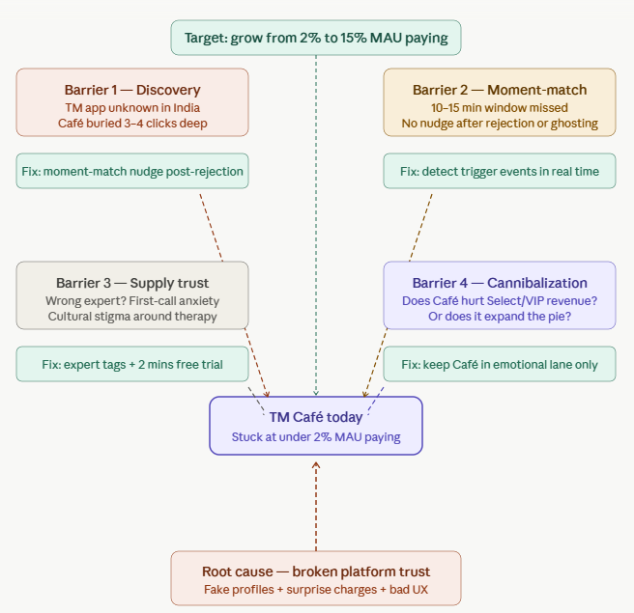

Barrier 1 — The Discovery Barrier
TM Café has a discovery problem at two levels not one.
The first level is the app itself. TrulyMadly is not well known in India. Most young Indians have heard of Tinder or Bumble. Very few outside metro cities know TrulyMadly exists. The app has 12 million registered users but compared to India's population and the size of the dating app opportunity, brand awareness is very low. Users who would benefit most from TM Café emotionally vulnerable young Indians in Tier 2 and Tier 3 cities are not even reaching the app in the first place.
The second level is inside the app. Even among users who do have TrulyMadly installed, TM Café is buried 3 to 4 clicks deep with no nudge pointing to it. A user can open TrulyMadly every day for months and never see that Café exists. The feature is invisible to the very users it is designed for.
Both levels need fixing. The outer discovery problem requires marketing and brand awareness. The inner discovery problem requires moment-match nudges inside the app at emotional trigger points.
Fix: Surface TM Café through a moment-match nudge right after rejection, unmatch, or ghosting before the user exits the app.

Barrier 2 — The Moment-Match Barrier
Even users who know TM Café exists do not open it at the right time. The window between an emotional trigger and a user being open to help is approximately 10 to 15 minutes. After that they move on they scroll reels, call a friend, or just go to sleep.
TrulyMadly currently does nothing in that window. No nudge appears after a rejection. No prompt appears after a ghosted conversation. No notification goes out on Sunday evenings when loneliness peaks. The moment passes and the opportunity is gone.
This is the single biggest product gap in TM Café today. A bottom sheet that says "Feeling low? Talk to someone first 2 minutes free" at the exact right moment would change the conversion rate entirely. The research showed this clearl users are open to help at that moment, but nothing is there to catch them.
Fix: Detect emotional trigger events in real time unmatch, 5 failed swipes, Sunday 9pm — and surface a Café nudge immediately.

Barrier 3 — The Supply-Trust Barrier
Even users who land on TM Café face a new problem which expert do I pick and why should I trust them?
The current expert listing shows names, photos, and ratings. But it does not tell users what each expert specialises in. A user who just got ghosted does not know whether they need a Coach or a Listener. A user dealing with arranged marriage pressure does not know which astrologer understands their situation.
On top of this is first-call anxiety a uniquely Indian problem. Talking to a stranger about personal and emotional problems is a completely new concept in India. There is cultural discomfort, stigma around therapy, and a general hesitation to open up to someone you have never met. Research showed that most Indian users — especially men would not make this call unless the first 2 to 3 minutes were completely free and low risk.
Once they experience warmth and non-judgment in those first few minutes, the discomfort disappears and they are willing to pay. Without the free trial, the barrier remains.
Fix: Add specialisation tags to every expert bio. Offer 2 minutes free with every new expert. Train experts to open every session with warmth in the first 60 seconds.

Barrier 4 — The Monetization Cannibalization Risk
This is the business question TrulyMadly must answer honestly. If users start paying ₹300 for TM Café sessions, will they stop paying ₹799 for Select or VIP subscriptions?
The research suggests these are two completely different needs. Select and VIP are about getting more matches more swipes, better visibility, profile boosts. TM Café is about dealing with the emotional side of dating the rejections, the anxiety, the confusion. A user pays for Select because they want more matches. They pay for Café because a match went wrong or did not happen at all.
These two are complementary not competing. The risk of cannibalization is low if TM Café is positioned correctly in the emotional support lane and kept away from features that overlap with Select like profile makeovers or matching advice.
Fix: Trigger Café only from emotional moments after rejection, after unmatch, after a bad date. Never position Café as a substitute for dating features.

Repeat-Use Breakdown — Where Users Drop Off After First Call
Getting a user to their first Café call is hard. Getting them back for a second call is even harder. Approximately 40% of users who complete a first call do not return within 14 days. Here is why:
- No follow-up message from the expert after the session
- No recap or summary of what was discussed
- No reminder or check-in nudge from the app
- The emotional moment has passed and the habit has not formed yet
- No clear reason to come back the user feels slightly better but not connected enough to rebook
Fix: After every first call expert sends a check-in on Day 3. App sends a nudge on Day 7 saying "How are you feeling now?" This creates a reason to return before the habit breaks.

Conversion Insights What Turns a Free User Into a Paying Café User
Three things need to happen in sequence:
First an emotional trigger occurs. Rejection, ghosting, loneliness. This happens naturally but TM Café currently does nothing to catch it.
Second a moment-match nudge appears inside the app within 10 minutes of the trigger. The copy must be specific "Feeling low after that unmatch? Talk to someone" converts better than a generic "Visit TM Café."
Third the first 2 to 3 minutes must be free. Indian users will not pay before feeling value. Once they experience genuine help in those free minutes, payment follows naturally. Astrotalk has proven this at scale.

India-Specific Insights
Cultural discomfort with talking to strangers Talking to a stranger about relationship problems is new in India. Most people process these feelings with close friends or family. The stigma around emotional vulnerability is real — especially among young men. The 2-minute free trial is not just a pricing tactic. It is a cultural bridge that gives users a low-risk way to try something unfamiliar.
Pricing sensitivity across tiers Tier 1 users will pay ₹300 to ₹500 per session if value feels clear. Tier 2 and Tier 3 users need ₹99 to ₹149 as the entry point. Per-minute pricing creates anxiety. Flat session pricing feels predictable and fair.
Language as a barrier 54% of TrulyMadly's new users come from Tier 2 and Tier 3 cities where people are more comfortable in Hindi or regional languages. Asking someone to discuss their feelings in a second language adds unnecessary friction. Hindi-speaking coaches are a conversion requirement not a nice-to-have.
UPI as the payment default Indian users are comfortable with UPI for small payments. A pre-filled ₹199 UPI payment with one tap removes all friction. Any payment flow that takes more than 2 steps will lose users at the last moment.

Conclusion
TM Café is under-scaled for four connected reasons the app itself is unknown, the feature is buried inside it, users miss the emotional trigger window, experts are hard to trust, and the platform's existing credibility problem poisons every paid interaction.
The good news is that each barrier has a clear fix. Discovery is solved by brand awareness and moment-match nudges. Moment-match is solved by detecting emotional trigger events in real time. Supply-trust is solved by specialisation tags and a 2-minute free trial. Cannibalization is avoided by keeping Café strictly in the emotional support lane.
None of these fixes require rebuilding TrulyMadly from scratch. They require smart product decisions layered on top of what already exists. That is what Steps 3 through 7 will define.

Step 3
SOLUTION IDEATION & PRIORITIZATION

Step 2 identified four barriers keeping TM Café stuck discovery, moment-match, supply trust, and cannibalization risk. Step 3 proposes 15 solutions across these barriers, scores each one using the RICE framework, and shortlists the 2 highest-impact solutions to build first.
Every solution below is directly grounded in the research from Steps 1 and 2. Discovery solutions come from the finding that TrulyMadly itself is unknown and Café is buried inside it. Moment-match solutions come from the 10 to 15 minute emotional window identified in user research. Supply-trust solutions come from first-call anxiety and the Astrotalk freemium benchmark. Pricing solutions come from willingness-to-pay research across Tier 1 and Tier 2/3 users.
Indian dating or emotional support app is serving today. This expands TM Café's addressable market and creates genuine differentiation from Astrotalk and YourDost.

No. | Solution | Category | Barrier Addressed | Description | Evidence Source
S1 | First 2 Minutes Free with Every Expert | Conversion | Paywall barrier + Trust gap | A free trial that allows users to experience expert value before paying, reducing hesitation and significantly improving first paid session conversion | Users hesitant to pay without proof. Competitor validation (Astrotalk free minutes). Interviews: “not sure if worth paying”
S2 | Moment-Match Entry System with AI Concierge & Gamification | Activation + Retention | Discovery barrier + Moment-match gap + Guidance confusion | A unified system that detects emotional triggers (ghosting, rejection, inactivity), nudges users into Café, uses AI to understand user context and recommend relevant experts, and builds a gamified profile (check-ins, streaks, quizzes) to improve personalization and repeat engagement over time | User interviews: users feel low after ghosting/rejection. App reviews: “no help when conversations fail.” High drop-off after emotional events
S3 | Tier 2/3 PPP Pricing (₹99 Entry Point) | Conversion | Price sensitivity (India-specific) | Introduces affordable ₹99 pricing for Tier 2/3 users, improving accessibility and expanding the paying user base | India market insight: high price sensitivity. Interviews show lower WTP in Tier 2/3 segments
S4 | Sunday 9PM Loneliness Push Notification | Activation | Timing gap | Triggers nudges during peak emotional vulnerability (Sunday nights), increasing entry into Café | Behavioral pattern: loneliness spikes during weekends
S5 | Verified Expert Badges & Ratings Visibility | Trust | Supply-trust barrier | Displays verified badges, ratings, and session counts to improve credibility and reduce hesitation | Users report lack of trust in experts
S6 | Post-Ghosting Nudge (48h Inactivity) | Activation | Moment-match gap | Detects inactive conversations and nudges users toward Café at the right emotional moment | Users disengage after chats go cold
S7 | Café Tile in Swipe/Feed Flow | Discovery | Discovery barrier | Surfaces Café within the main swipe/feed journey to improve visibility and access | Users unaware of Café feature
S8 | Day 3 & Day 7 Follow-up Check-ins | Retention | Repeat usage gap | Sends follow-up nudges post-session to encourage repeat usage and build habit | Retention drops after first session
S9 | Post-Date Debrief Prompt | Engagement | Missed moment capture | Prompts users after dates to reflect and seek guidance, increasing contextual engagement | Users unsure after dates
S10 | LGBTQ-Safe Listener Category | Expansion | Inclusivity gap | Provides a safe and inclusive support category for LGBTQ users | Underserved segment needs safe support
S11 | Festival Loneliness Campaigns | Activation | Cultural timing gap | Runs campaigns during emotional peaks (Diwali, Valentine’s) to drive engagement | Indian emotional spikes during festivals
S12 | Social Media Retargeting Campaigns | Growth | Awareness gap | Retargets users with emotional messaging to bring them back into Café | Users churn without re-engagement
S13 | Rebrand TM Café (Name + UI Refresh) | Discovery | Positioning gap | Repositions Café as an emotional support feature through | Users unclear about Café purpose

Top 2 Shortlisted Solutions

1. First 2 Minutes Free (Free Trial)
This solution directly removes the biggest barrier hesitation to pay without experiencing value.
By allowing users to try the service risk-free, it increases trust, improves first-time engagement, and drives higher conversion into paid sessions.

2. Moment-Match Entry System with AI Concierge & Gamification
This combined system creates a full user lifecycle:
- Moment-match nudges bring users into Café at the right emotional time
- AI concierge reduces confusion and matches users to the right expert
- Gamification & data personalize future experiences and improve retention
This transforms TM Café from a one-time service into a continuous engagement loop.
Why These 2 Together
These solutions work as a complete funnel:
- Entry → Moment-match nudges
- Conversion → Free trial
- Retention → AI + gamification
Together, they:
- Increase user inflow into Café
- Improve conversion to paid sessions
- Build long-term engagement and repeat usage

RICE Prioritization
The solutions were evaluated using the RICE framework:
- Reach → number of users impacted monthly
- Impact → effect on conversion/revenue (1–4 scale)
- Confidence → certainty based on research
- Effort → time/complexity (in months)

RICE Table (Top Solutions)
# | Solution | Reach | Impact | Confidence | Effort | RICE Score
1 | First 2 mins free with every expert | 50,000 | 4 | 1.0 | 1 | 200,000
2 | Moment-Match Entry System with AI Concierge & Gamification | 30,000 | 4 | 0.8 | 3 | 32,000
3 | Tier 2/3 PPP pricing ₹99 | 12,000 | 3 | 0.8 | 1 | 28,800
4 | Sunday 9pm push notification | 10,000 | 2 | 0.8 | 0.5 | 32,000
5 | Verified expert badges | 8,000 | 2 | 1.0 | 0.5 | 32,000
6 | Post-ghosting nudge | 7,000 | 3 | 0.8 | 1.5 | 11,200
7 | Café tile in swipe feed | 6,000 | 2 | 0.8 | 1 | 9,600
8 | Day 3 & Day 7 check-in | 5,000 | 3 | 0.8 | 1 | 12,000
9 | Post-date debrief prompt | 4,000 | 2 | 0.8 | 1 | 6,400
10 | LGBTQ-safe listeners | 3,000 | 4 | 0.8 | 2 | 4,800
11 | Festival loneliness campaigns | 4,000 | 2 | 0.8 | 2 | 3,200
12 | Social media retargeting | 5,000 | 2 | 0.5 | 3 | 1,667
13 | Rebrand TM Café — new UI | 4,000 | 3 | 0.5 | 6 | 1,000

Shortlisted Solutions
1. First 2 Minutes Free
Highest direct impact on conversion
- Removes payment hesitation
- Proven model (high confidence)
- Fast to implement
Directly increases paying users

2. Moment-Match Entry System with AI Concierge & Gamification
- Captures users at emotional moments
- Improves expert matching via AI
- Builds personalization through gamification
- Drives long-term retention
Impacts both acquisition and retention

Why These 2 Were Selected
Although some solutions like expert tags and Sunday push show high RICE scores due to low effort, they are supporting optimizations and do not directly solve the core funnel problem.
The selected solutions were chosen because they:
- Directly impact user entry and conversion
- Address multiple barriers simultaneously
- Work together as a complete system

Combined Impact
- Moment-match + AI system → increases user inflow and engagement
- Free trial → converts users into paying customers
Together, they create a full funnel:
Entry → Conversion → Retention

Conclusion
The prioritization balances short-term impact and long-term scalability.
While the free trial drives immediate conversion, the AI-driven system builds a sustainable engagement loop, making these two the most effective solutions for achieving the target metrics.

6-Month Product Roadmap
Month | Phase | Focus Area | Key Features / Solutions Launched | Target Paying Users | Success Metric
1 | Power User Cohort | Foundation | First 2 mins free with every expert · Moment-match nudge (post-rejection, post-unmatch) | 7,500 | 15% of cohort completes first Café call
2 | Power User Cohort | Activation | Post-ghosting nudge (48h inactivity) · Sunday 9pm push · Verified expert badges | 10,000 | Nudge CTR hits 15% · Free-to-paid conversion 40%
3 | Tier 1 City Rollout | Conversion | AI Concierge live · Expert specialisation tags · Day 3 & Day 7 check-in nudges | 25,000 | Free trial completion 80% · Expert rating avg 4.6
4 | Tier 1 City Rollout | Retention | Gamification streaks · Post-call emotional check-in · Café tile in swipe/feed | 35,000 | D14 repeat rate 40% · Wallet recharge frequency 2x
5 | Tier 2/3 Rollout | Scale | Hindi sessions · ₹99 flat session pricing · UPI one-tap payment · Diwali/Karwa Chauth festival campaigns | 55,000 | 8% of Tier 2/3 cohort converts to paying
6 | Full MAU | Growth | LGBTQ-safe listeners · Advanced AI personalisation · Creator-led coach content · Refer-a-friend gifting mechanic | 75,000 | 15% of MAU paying · Café revenue = 30% of total revenue

STEP – 4
DESIGN EXPERIENCE AND PROTOTYPE

Introduction
Step 3 shortlisted two solutions first 2 minutes free with every expert and the AI Smart Concierge with gamification. Step 4 translates these into a concrete product experience. The prototype demonstrates the complete end-to-end journey from emotional trigger to first paid call to 7-day retention showing exactly how TM Café earns trust before asking for payment.

User Journey Map
The complete journey has 7 stages:
Stage 1 — Emotional trigger occurs. User gets ghosted, rejected, or feels lonely. The app detects the signal an unmatch event, 5 failed swipes, or 48 hours of chat inactivity.
Stage 2 — Moment-match nudge appears. A bottom sheet appears immediately "That didn't go well, right? Talk to someone who understands first 2 mins free." The nudge is warm, specific, and low-commitment.
Stage 3 — AI Smart Concierge opens. User taps the nudge and lands on the AI concierge not a cold expert listing. The AI asks what happened "Got ghosted, Bad date, Feeling lonely, Nervous to text." Based on the answer it recommends the right expert type with context pre-filled.
Stage 4 — Expert selection. User sees a curated list of experts matched to their situation coaches who specialise in ghosting recovery, listeners for emotional support, astrologers for compatibility. Every expert shows a 2 mins free badge, rating, session count, and a short personal quote. Trust is built before the call starts.
Stage 5 — Free trial call begins. User starts a call. A live timer shows "Free time left 1:42." After 2 minutes a gentle prompt appears "Want to keep going? Continue at ₹14/min." Users who felt value continue. Users who did not leave without feeling cheated.
Stage 6 — Post-call check-in. After the call the app asks "How are you feeling now?" with three honest options Better, Same, Worse. The answer feeds the personalisation engine and improves future expert recommendations.
Stage 7 Gamification and retention. The user sees their Café journey current streak, emotional progress, sessions done, Café points. A 5-day streak unlocks 5 free minutes. This creates a daily habit loop that brings users back before the emotional memory of the first session fades.

How the Moment-Match Nudge Works
The nudge is triggered by three behavioural signals detected in real time inside the TrulyMadly app:
Signal 1 — Unmatch event. When a match unmatches the user, the nudge appears within 30 seconds.
Signal 2 — Swipe failure pattern. After 5 consecutive left swipes with no right swipe returned, the nudge appears.
Signal 3 — Ghosted conversation. When a chat has been inactive for 48 hours after the user sent the last message, a nudge appears in the chat tab.
The copy is personalised to the signal ghosting gets "That didn't go well, right?" and swipe failure gets "Feeling low after a rough evening?" This specificity makes the nudge feel human rather than automated.

How Supply Trust is Built
Trust is built at four points in the journey:
Expert cards show rating, session count, specialisation badge, and a personal quote not a generic bio. A user who just got ghosted sees coaches tagged "Breakup Coach" and "Communication Expert" not a generic list.
The 2 minutes free badge appears on every expert card. This removes payment anxiety before the call starts.
The AI concierge opens every interaction with warmth "Hey, I'm here to listen. What happened?" before showing any expert or pricing. This mirrors the warmth that drives Astrotalk's high repeat rates.
The free trial call shows a live countdown timer so users always know exactly how much free time remains. No hidden charges, no surprise billing directly addressing the Trust-Skeptic persona identified in research.

How the Experience Feels Local
Hindi language option available on the AI concierge opening screen "Hindi mein baat karein?" for Tier 2 and Tier 3 users.
UPI payment is the default payment method pre-filled at ₹199 wallet top-up with one-tap confirmation.
Expert specialisation tags include "Arranged marriage advice" and "Toxic relationship recovery" culturally specific situations that generic therapy apps do not address.
Gamification uses Indian cultural references streaks during festival seasons unlock special badges, Diwali loneliness check-ins trigger bonus Café points.

Prototype Links
Full 7-screen interactive prototype all new TM Café screens: https://tmcafe.lovable.app
Existing TrulyMadly experience — before state showing dating feed, chat tab, and buried Café tab: https://trulymadly.lovable.app

Screens Covered
New screens — 7 screens built in prototype:
- Moment-match nudge overlay
- AI Smart Concierge chat interface
- Expert recommendation listing with free trial badges
- Live call screen with free trial timer
- Payment continuation prompt
- Post-call emotional check-in
- Gamification and streak dashboard
Existing screens — 3 screens showing before state:
- TrulyMadly dating swipe feed
- Chat tab showing buried Café entry point
- Current TM Café home screen before redesign

Conclusion
The prototype demonstrates a complete trust-first experience — the user never sees a payment screen before feeling genuine value. Every screen in the journey is designed around one insight from the research: Indian users will pay for emotional support if the first experience removes risk and feels warm. The gamification layer ensures that first experience becomes a habit which is what moves revenue share from 5% to 30% over 12 months.

User Journey map
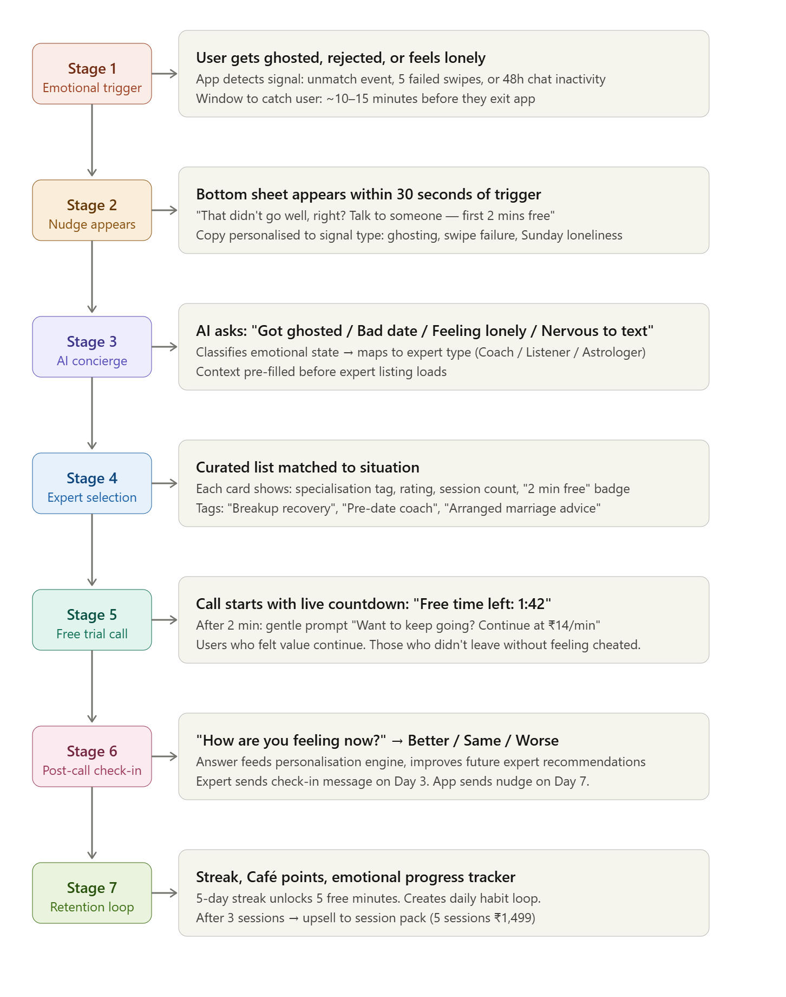

STEP 5:
GO-TO-MARKET, GROWTH LOOP & MONETIZATION ANALYSIS

Introduction
Steps 3 and 4 defined what to build and what it looks like. Step 5 defines how to launch it, grow it, and make it generate repeatable revenue. The goal is to move TM Café from under 2% to 15% of MAU paying and from 5% to 30% of total revenue within 6 to 12 months.
Three engines drive this: a retention loop that brings users back weekly, a growth loop that turns happy users into acquisition channels, and a monetization flywheel that moves users from free to paying to high-ticket.

India GTM Plan
Phase 1 — Months 1 to 2 — Power User Cohort
Launch to the top 10% most active TrulyMadly users first users who open the app 4 or more times per week and have been active for 3 or more months. This cohort is most likely to experience rejection and ghosting moments regularly, most likely to engage with the moment-match nudge, and most likely to give quality feedback if something breaks.
Target: 50,000 users in Phase 1. Success signal: 15% of Phase 1 users complete a first Café call within 2 weeks.
Phase 2 — Months 2 to 4 — Tier 1 City Rollout
Roll out to all active TrulyMadly users in Tier 1 cities Mumbai, Delhi, Bengaluru, Hyderabad, Chennai, Pune. These users have higher willingness to pay and are more comfortable with new digital products. Introduce the full feature set moment-match nudge, AI concierge, freemium trial, gamification streaks.
Target: 200,000 users in Phase 2. Success signal: 10% of Phase 2 users become paying Café users within 30 days.
Phase 3 — Months 4 to 6 — Tier 2 and Tier 3 Rollout
Roll out to Tier 2 and Tier 3 cities with India-specific adaptations Hindi and regional language sessions, ₹99 flat session pricing, UPI as default payment, festival campaign activations around Diwali and Karwa Chauth.
Target: 300,000 users in Phase 3. Success signal: 8% of Phase 3 users become paying Café users within 30 days.
Festival Campaign Calendar
Festival | Date | Campaign | Special offer
Karwa Chauth | October | Relationship advice for couples and singles | 3 sessions for ₹299
Diwali | November | Festival loneliness campaign | First session free
New Year | January | New year new me — dating reset | Profile makeover coach pack
Valentine's Day | February | Pre-date coaching and breakup recovery | 2x Café points
Holi | March | Meet someone new — confidence coaching | ₹99 first session

Revenue Model
ARPU by Segment
Segment | Sessions per month | Avg session price | Monthly ARPU | Annual LTV
Post-Breakup Healer | 3 | ₹400 | ₹1,200 | ₹8,400
Chronic Lonely | 4 | ₹250 | ₹1,000 | ₹12,000
Pre-Date Prepper | 2 | ₹300 | ₹600 | ₹3,600
Relationship Overthinker | 5 | ₹400 | ₹2,000 | ₹18,000
Tier 2/3 General | 2 | ₹99 | ₹198 | ₹1,584

Wallet Recharge LTV
Average wallet top-up: ₹399 Average recharges per month per paying user: 1.5 Monthly wallet revenue per paying user: ₹599 If 15% of 500,000 MAU pay = 75,000 paying users Monthly wallet revenue: 75,000 × ₹599 = ₹4.49 Cr per month Annual wallet revenue: ₹53.9 Cr
Take Rate Economics
TM Café takes 30% of every session as platform fee. Expert earns 70% of session value. At ₹400 session TM takes ₹120, expert earns ₹280. At scale of 75,000 paying users doing 3 sessions per month: Monthly GMV = 75,000 × 3 × ₹300 average = ₹6.75 Cr TM revenue at 30% take rate = ₹2.02 Cr per month Annual TM Café revenue = ₹24.3 Cr
Combined with wallet recharge revenue this puts TM Café at ₹78 Cr annually — approaching the ₹100 Cr target within 18 months as the user base grows.

Monetization Flywheel
The flywheel has 5 stages each stage feeds the next:
Stage 1 — Free dating user opens TrulyMadly to swipe and match.
Stage 2 — Emotional trigger occurs rejection, ghosting, loneliness. Moment-match nudge appears. User discovers TM Café for the first time.
Stage 3 — AI concierge routes user to right expert. First 2 minutes free removes payment barrier. User completes first paid call. Wallet is recharged with ₹199.
Stage 4 — Day 3 and Day 7 check-ins bring user back. Gamification streak creates daily habit. User recharges wallet again ₹399 this time for the bonus credit.
Stage 5 — After 3 to 5 sessions user upgrades to a session pack 5 sessions for ₹1,499. Higher ticket size, higher LTV, stronger habit.
The flywheel accelerates because each positive session makes the next session more likely the AI personalisation engine gets smarter, the expert relationship deepens, and the gamification streak creates loss aversion that keeps users coming back.

Growth Loop
TM Café has three growth loops working simultaneously:
Loop 1 — Word of mouth through outcomes User has a great first session → feels better → goes on a better date or handles rejection better → tells a friend not "I used a coach" but "things got better, I feel more confident." Friend asks how. User shares the app. Referral happens organically without the stigma of "I went to therapy."
The product mechanic: After a positive post-call check-in, show a prompt "Gift your friend 2 free minutes they don't need to know why, just that it helped you." This makes sharing feel like gifting, not confessing.
Loop 2 — Creator-led content from coaches TM Café coaches create short dating advice content "3 things to do after getting ghosted", "How to start a conversation on a dating app" posted on Instagram and YouTube with a link to book a session. Coach builds their personal brand, TM Café gets free acquisition. Both win.
Loop 3 — Listener to Coach supply flywheel Listeners who perform well are offered Coach training. This creates a supply pipeline that grows with demand the better TM Café does, the more experts it creates, the better the supply quality becomes. Expert retention improves because earnings grow as they move from Listener to Coach.
Growth loop diagram — metrics at each step:
Step | Action | Metric | Target
1 | User experiences trigger | Trigger events per day | 10,000+
2 | Nudge shown | Nudge impression rate | 75% of triggered users
3 | User taps nudge | Nudge CTR | 15%
4 | User completes free trial | Free trial completion rate | 70%
5 | User makes first payment | Free to paid conversion | 40%
6 | User returns in 14 days | D14 repeat rate | 40%
7 | User refers a friend | Referral rate | 10% of happy users
8 | New user acquired | Viral coefficient | 0.3

Retention Loop
The retention loop is built around the emotional recovery arc the idea that healing from rejection or loneliness is not a one-session fix. It takes time and multiple touchpoints.
Week 1 — First session. User feels slightly better. Day 3 check-in from expert. Day 7 nudge from app.
Week 2 — User returns for second session. Streak hits 7 days. Gamification unlocks a reward 5 free minutes. User feels progress.
Week 3 — User books a session pack. Habit is formed. Expert relationship deepens.
Week 4 onwards — User becomes a regular. ARPU increases. They recommend TM Café to friends using the gifting mechanic.
The emotional recovery arc is what separates TM Café from Astrotalk. Astrotalk sells predictions — one-off consultations. TM Café sells progress — a journey. This is what drives the higher LTV per user shown in the revenue model above.

Cohort Analysis
Cohort | Trigger moment | D1 retention | D7 retention | D30 retention | Avg sessions month 1 | ARPU month 1
Post-rejection | Unmatch or swipe failure | 65% | 45% | 30% | 2.5 | ₹750
Post-ghosting | Chat inactive 48 hrs | 60% | 40% | 25% | 2 | ₹600
Sunday lonely | Sunday 9pm nudge | 50% | 35% | 20% | 1.5 | ₹375
Festival | Diwali or Valentine's | 70% | 30% | 15% | 1.5 | ₹450
Organic | Found Café without nudge | 40% | 20% | 10% | 1 | ₹300
Key insight: Moment-matched cohorts post-rejection and post-ghosting have significantly higher D7 and D30 retention than organic discovery cohorts. This validates the core strategy of moment-match nudges as the primary acquisition channel.

Expert Onboarding Funnel
Stage | Description | Target
Application | Expert applies via TM Café expert portal | 500 applications per month
Screening | Background check, credential review, trial session | 200 pass screening
Training | 2-week onboarding — warm opening, Indian cultural context, first-call anxiety handling | 150 complete training
Trial period | First 10 sessions monitored, rating must be 4.3 or above | 120 pass trial
Live | Expert goes live on platform with verified badge | 100 new experts per month
Supply target: 200 active experts by Month 6 — 80 Coaches, 80 Listeners, 40 Astrologers.

Rollout Strategy Summary
Month | Phase | Users | Key feature live | Target paying users
1 to 2 | Power user cohort | 50,000 | Freemium trial + moment-match nudge | 7,500
2 to 4 | Tier 1 cities | 200,000 | AI concierge + gamification | 25,000
4 to 6 | Tier 2 and Tier 3 | 300,000 | Hindi sessions + ₹99 pricing + festival campaigns | 50,000
6 to 12 | Full MAU | 500,000 | LGBTQ listeners + advanced AI personalisation | 75,000
75,000 paying users out of 500,000 MAU = 15% — hitting the exact target set in the case study problem statement.

Growth loop diagram
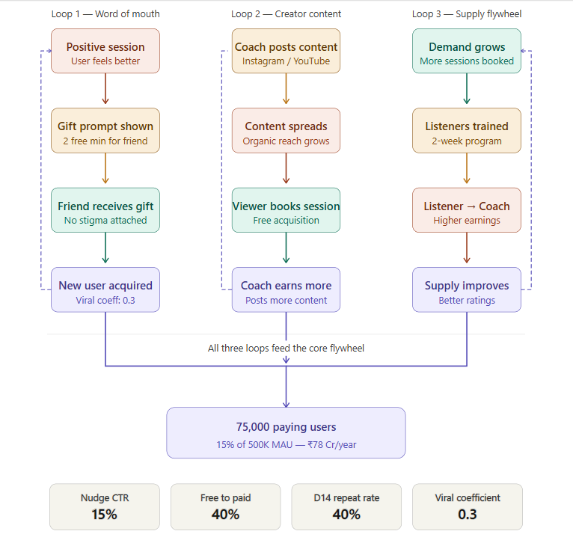

Trigger → Nudge → Entry → AI Routing → Expert → Free Trial → Payment → Feedback → Retention → Repeat

Activation + Retention Flow

1. Emotional Trigger
Event:
- Chat inactive (ghosting)
- Bad date
- Rejection
System action:
- Detect trigger
Output:
- Nudge shown
Example CTA:
- “Talk to someone now”

2. Nudge → Entry
User clicks nudge
System:
- Opens TM Café
Screen:
- “What’s going on?”
- Options:
  - Got ghosted
  - Bad date
  - Feeling low
  - Or text input

3. AI Concierge (Guidance Layer)
User selects or types input
System:
- Classifies problem
- Maps to expert type
Output:
- Suggested experts
Example:
- “Best for ghosting recovery”
- “Top rated breakup coach”

4. Expert Selection
User views expert profiles
Screen shows:
- Rating
- Specialization
- Experience
- “2 mins free” label
CTA:
- Start session

5. Free Trial (Conversion Entry)
Session starts
System:
- Shows countdown timer (2 minutes free)
User experiences value before payment

6. Payment Conversion
After free time ends
Prompt:
- “Continue session?”
Options:
- Continue (paid)
- End
User chooses to pay → conversion

7. Post-Session Feedback
After session ends
Prompt:
- “How are you feeling now?”
Options:
- Better
- Same
- Worse
Data stored for personalization

8. Retention Trigger (Day 3 / Day 7)
System sends follow-up
Example:
- “Still thinking about it? Talk again”
User re-enters Café

9. Repeat Session
System shows:
- Same expert OR better match
- Personalized suggestion
Example:
- “Recommended for you”

10. Light Personalization Layer
System tracks:
- User patterns
- Emotional triggers
- Past sessions
Output:
- Better nudges
- Better expert matching

Full Flow Summary

Conclusion
The GTM strategy is built on one core insight from the research Indian users will pay for emotional support if the entry is low-risk, the experience feels warm and culturally relevant, and the value is felt before the payment. The phased rollout ensures quality is maintained as scale increases. The three growth loops word of mouth, creator content, and supply flywheel create organic acquisition that reduces paid marketing dependence over time. The monetization flywheel moves users from free to paying to high-ticket systematically hitting the ₹100 Cr revenue target within 18 months

Step-6
METRICS AND SUCCESS MEASUREMENT

Introduction
A product without clear metrics is just a feature. Step 6 defines exactly how we know if TM Café is winning what we measure, what targets we set, what signals warn us early if something is going wrong, and what events we track to understand every step of the user journey.

North Star Metric
Chosen: % of MAU who are paying Café users
Target: Grow from under 2% to 15% of MAU within 12 months.
This metric was chosen over raw Monthly Paying Café Users and over Café Revenue per MAU for a specific reason. Raw paying user counts can look good simply because the overall app is growing not because Café is improving. Revenue per MAU counts passive users who open the app by accident. % of MAU who are paying Café users is the cleanest signal it measures what fraction of TrulyMadly's active base has made a real decision to pay for emotional support through Café. It scales with the app, cannot be gamed by overall growth, and directly reflects whether TM Café is delivering genuine value to the right users at the right moment.
At 500,000 current MAU, 15% means 75,000 paying users per month. That is the single number the entire product team optimises toward.

Initiative Metrics and Targets
These are the metrics that directly drive the North Star. Each one maps to a specific step in the trigger-to-payment funnel.
Metric | What it measures | Current estimate | Target | Timeline
Trigger-to-nudge rate | % of triggered users who see the moment-match nudge | 45% | 75% | Month 2
Nudge CTR | % of users who tap the nudge after seeing it | 8% | 15% | Month 2
Free trial completion rate | % of users who complete the 2-minute free trial | 60% | 80% | Month 3
Free to paid conversion | % of free trial users who continue to paid session | 20% | 40% | Month 3
First call to second call retention | % of users who book a second session within 14 days | 20% | 40% | Month 4
Wallet recharge frequency | Average wallet top-ups per paying user per month | 1 | 2.5 | Month 6
Expert quality score | Average expert rating across all sessions | 4.3 | 4.6 | Month 3
Cross-sell rate from dating to Café | % of dating users who try Café after rejection or unmatch | 2% | 12% | Month 4
AI concierge completion rate | % of users who complete AI concierge flow before expert listing | 50% | 75% | Month 4
Gamification streak rate | % of paying users maintaining a 7-day streak | 0% | 25% | Month 6

Supporting Signals
Leading Indicators — early signals of growth
- Daily nudge impressions — how many moment-match nudges are shown per day. Rising number means more emotional trigger moments are being caught.
- AI concierge session starts — how many users open the AI concierge per day. Rising number means discovery is working.
- Free trial starts per day — how many users begin a free trial. This predicts paid conversions 24 to 48 hours later.
- 7-day streak count — how many users have an active gamification streak. Rising number predicts strong D30 retention.
Lagging Indicators — confirmation of outcomes
- % of MAU paying Café users — the North Star. Confirmed at end of each month.
- Total Café revenue — confirms monetization flywheel is working.
- Average sessions per paying user per month — confirms repeat use habit is forming.
- Expert NPS — net promoter score from experts confirms supply side is healthy.
Guardrail Metrics — warning signals
Guardrail | What it monitors | Threshold | Action if breached
Subscription cannibalization | % of Select and VIP users who reduce subscription spend after using Café | 10–15% | Pause Café cross-sell, investigate overlap
Expert quality drop | Average expert rating falls below threshold | Below 4.3 | Suspend low-rated experts, trigger retraining
Expert burnout rate | % of active experts reducing session availability by 50%+ | Above 20% | Cap session hours, review pay rates
User wellbeing flag | % of sessions where user reports feeling worse after call | Above 5% | Audit expert sessions, review call recordings
Safety flag rate | % of sessions flagged for inappropriate content | Above 1% | Immediate expert suspension, safety review
First-call refund rate | % of users requesting refund after first paid session | Above 8% | Review expert quality, audit AI routing accuracy

Metrics Dashboard
Daily Dashboard — operations team reviews every morning
- % of MAU paying Café users today vs yesterday
- Nudge impressions today
- Free trial starts today
- Paid conversions today
- Expert quality score today
- Safety flags today
- Active streaks today
Weekly Dashboard — product team reviews every Monday
- Trigger-to-nudge rate this week vs last week
- Nudge CTR this week vs last week
- Free to paid conversion this week vs last week
- First call to second call retention this week
- New experts onboarded this week
- Cannibalization rate this week
Monthly Dashboard — leadership reviews end of month
- % of MAU paying Café users vs 15% target
- Café revenue share vs total TrulyMadly revenue vs 30% target
- ARPU by persona segment
- D30 retention by trigger cohort
- Expert NPS
- Wallet recharge LTV
- Cannibalization rate vs 10–15% threshold

Event Tracking Specification — Top 15 Events
# | Event name | When it fires | Key property captured
1 | Trigger moment detected | App detects unmatch, swipe failure, or ghosting | trigger_type — unmatch, swipe_fail, ghost
2 | nudge impression | Moment-match bottom sheet shown to user | nudge_copy_variant, trigger_type
3 | nudge tapped | User taps the nudge CTA | time_since_trigger, nudge_copy_variant
4 | Café home opened | User lands on TM Café home screen | source — nudge, organic, push
5 | Ai concierge started | User begins AI concierge flow | entry_source
6 | Emotion selected | User selects emotional state in AI concierge | emotion_type — ghosted, bad_date, lonely, nervous
7 | Expert recommended | AI concierge shows expert recommendation | expert_type, specialisation_tag
8 | Expert profile viewed | User taps on an expert card | expert_id, expert_type, source
9 | Free trial started | User starts 2-minute free trial call | expert_id, expert_type
10 | Free trial completed | User completes full 2 minutes | Expert id, call_duration
11 | payment_initiated | User taps continue after free trial | amount, payment_method — UPI, wallet
12 | payment_completed | UPI or wallet payment confirmed | amount, payment_method, expert_id
13 | call_completed | User completes paid session | duration, expert_id, expert_type
14 | post_call_checkin | User submits how are you feeling response | feeling — better, same, worse
15 | second_session_booked | User books repeat session within 14 days | days_since_first_call, expert_id

How Metrics Connect to the North Star
Every metric connects directly to the North Star of % of MAU paying Café users:
- Events 1 to 3 — measure whether users are being caught at trigger moments
- Events 4 to 8 — measure whether discovery and trust are working
- Events 9 to 12 — measure whether the freemium model is converting
- Events 13 to 15 — measure whether users are coming back
If the North Star is not moving, these events tell you exactly which stage of the funnel is broken and where to focus first.

Conclusion
% of MAU paying Café users is the right North Star because it measures real value delivered at scale not passive traffic and not absolute numbers that can be inflated by overall app growth. The initiative metrics create a complete diagnostic system. The guardrail metrics ensure growth does not come at the cost of expert quality, user wellbeing, or existing subscription revenue. Together they give the TM Café product team everything needed to move fast, stay honest, and course-correct quickly.

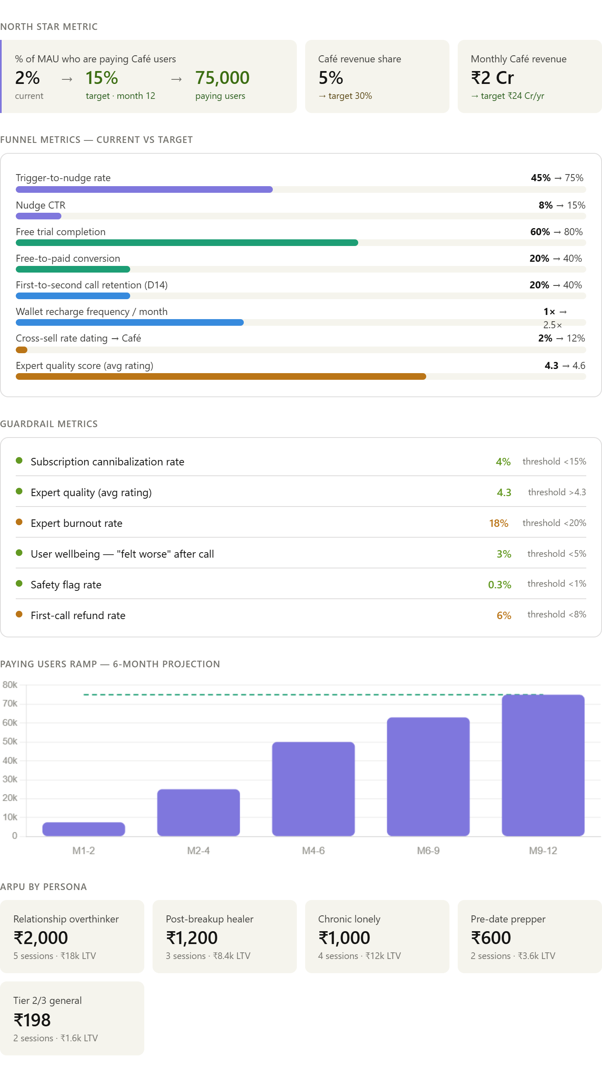

Step – 7
RISKS, TRADE-OFFS AND CONSTRAINTS
Introduction
Every product decision involves trade-offs. Step 7 demonstrates judgment about what could go wrong with the TM Café strategy not to argue against it, but to show that the risks have been thought through and mitigations are ready. A PM who cannot articulate risks is not ready to ship. A PM who has a mitigation for every risk is.

Key Risks with Mitigations
# | Risk | Likelihood | Impact | Mitigation
1 | Misuse for escort-type services | Medium | Very High | Clear community guidelines, AI moderation on call content, instant report button, 24-hour human review team, zero-tolerance suspension policy
2 | Expert burnout from free trial sessions | High | High | Cap free trial sessions per expert per day at 10, pay experts for free trial minutes at reduced rate, monitor session load weekly
3 | Supply-side quality drop at scale | High | High | Minimum 10-session trial before going live, mandatory retraining if rating drops below 4.3, quality review every 30 days
4 | Subscription cannibalization of Select and VIP | Medium | High | Position Café only at emotional trigger moments, never as substitute for dating features, monitor cannibalization rate weekly against 10-15% threshold
5 | Astrotalk moving into dating advice vertical | Medium | High | Build exclusive expert contracts, deepen TrulyMadly dating context advantage — Café knows what just happened to the user, Astrotalk does not
6 | Regulatory risk around telehealth and counselling | Low | Very High | Clearly position experts as coaches and listeners, not therapists or licensed counsellors. Add disclaimer on every session "This is not therapy."
7 | Data privacy around emotional conversations | Medium | Very High | End-to-end encryption on all calls, no call recording without explicit consent, GDPR and IT Act compliance, separate data storage for Café session data
8 | Expert misrepresenting credentials | Medium | High | Background verification for all coaches, no fake credential claims allowed in bios, report mechanism for users
9 | Free rider problem — users exploit free trial | High | Medium | Limit free trial to one per expert per user, not one per day. After free trial with all available experts is exhausted, no more free minutes.
10 | Hindi and regional language supply gap | High | Medium | Partner with regional coaching communities, hire a dedicated supply manager for Tier 2/3 cities, launch Tier 2/3 cities only after 50 Hindi-speaking experts are live

Trade-offs and Rationale
Trade-off 1 — Freemium generosity vs conversion pressure
Giving 2 minutes free removes the payment barrier and builds trust this is the strategy. But it also creates a free rider problem. Users can cycle through experts using free minutes without ever paying.
The resolution: limit the free trial to one per expert per user account. Once a user has used their free 2 minutes with a sp cific expert, they cannot get free minutes with that same expert again. They can try a new expert for free once but the total number e of free experts available is finite. This creates conversion pressure without destroying the trust-building mechanism.
Chose freemium over a full paywall because Astrotalk's model proves it works at scale in India. The conversion rate uplift from freemium outweighs the free rider cost at current scale. This decision will be reviewed at Month 6 with actual data.
Trade-off 2 — Pure dating focus vs loneliness economy expansion
TrulyMadly was built as a dating app. Expanding into emotional support, relationship coaching, and astrology consultation changes the product identity. There is a risk that the core dating users feel the product is losing focus.
The resolution: keep TM Café entirely separate in terms of branding within the app. The dating experience stays clean. Café is only surfaced at emotional moments it never replaces dating features. Users who only want to swipe will never be forced into Café.
Chose loneliness economy expansion because the market data is too strong to ignore — Astrotalk's ₹1,600 Cr ARR proves Indian users will pay at scale. TrulyMadly has a unique advantage it knows exactly what emotional moment the user just experienced. Not using that context would be a wasted opportunity.
Trade-off 3 — Per-minute pricing vs flat session pricing
Per-minute pricing is familiar from Astrotalk and creates low commitment entry. But research showed it feels like a taxi meter users watch the clock and cannot relax into the session.
Flat session pricing removes the anxiety but requires a higher upfront commitment. For first-time users this creates hesitation.
The resolution: offer flat session pricing as the default, with per-minute as an option for users who explicitly prefer it. The free trial removes the upfront commitment anxiety for flat pricing users have already felt value before they see the price. Chose flat over per-minute as default because session quality is higher when users are not watching a timer.
Trade-off 4 — High-empathy listeners vs domain-expert coaches
Listeners have the highest emotional impact on users they create the strongest first-call experiences. But they earn the least, carry the highest emotional load, and have the highest churn rate. Coaches have more domain expertise but lower emotional warmth scores.
The resolution: route users through the AI concierge so the right type is matched to the right situation. Post-breakup users get Listeners. Pre-date preppers get Coaches. The AI routing prevents the wrong type from being used for the wrong situation. Invest more in Listener pay rates to reduce churn even if it compresses margins in the short term.
Trade-off 5 — Tier 1 premium pricing vs Tier 2/3 PPP pricing
Charging ₹99 in Tier 2/3 cities while charging ₹400 in Tier 1 creates a two-tier system. There is a risk that Tier 1 users discover the Tier 2/3 pricing and feel overcharged.
The resolution: price differentiation is based on detected city and device, not user choice. This is standard practice in Indian SaaS Swiggy, Zomato, and Netflix all use regional pricing. The risk of backlash is low if the pricing is not publicly marketed as a comparison. Chose PPP pricing because 54% of new TrulyMadly users come from Tier 2/3 cities — not serving them at the right price point means leaving half the market behind.

Constraints
Constraint | Description | Impact on product | Assumption made
UPI and Paytm payment rails | All payments must route through UPI or Paytm. No international payment gateways for core Indian users. | Payment flow must be UPI-first with one-tap confirmation. No card entry for first-time users. | UPI infrastructure is stable and handles micro-payments under ₹200 reliably
24/7 expert supply | Users may need help at 2am after a bad date or at 6am before a morning date. Experts need to be available across all hours. | Cannot guarantee instant matching at all hours without a large enough supply base. Below 200 active experts this is a real gap. | Minimum 200 experts live before full launch. Night-shift premium pay introduced for experts available between 11pm and 7am
Indian language NLP for session analytics | To understand session quality, dropout points, and emotional outcomes, session transcripts need NLP analysis in Hindi and regional languages. English NLP tools do not work for Hindi conversations. | Quality monitoring is limited for non-English sessions until Hindi NLP is integrated. | Hindi NLP integration planned for Month 4. Manual quality review for Hindi sessions in Months 1 to 3.
Per-minute compute and call quality costs | Audio and video calls have real infrastructure costs. Free trial minutes have zero direct revenue but full infrastructure cost. | Free trial generosity must be balanced against compute cost. At scale, 100,000 free trial minutes per day has a real cost. | Average free trial cost per user is approximately ₹8 to ₹12. At 40% conversion rate, each paying user costs ₹20 to ₹30 in trial infrastructure. This is acceptable given average first-session ARPU of ₹300 plus.
Content and call moderation at scale | Every audio and video call between a user and an expert needs content moderation to catch misuse, inappropriate interactions, and safety violations. At 10,000 sessions per day this cannot be fully manual. | AI-assisted moderation is required from Day 1. Full manual review only for flagged sessions. | AI moderation tool integrated before launch. Human review team of 5 moderators available 24/7 for escalations.

Conclusion
The ten risks identified above fall into three categories — trust and safety risks which are the most serious and require zero-tolerance policies, operational risks which require planning and investment but are solvable, and business model risks which require monitoring and course-correction based on real data.
The most important risk to address before launch is the misuse risk. A single incident of escort-type misuse going viral would permanently damage TM Café's brand on a dating platform. The mitigation — clear guidelines, AI moderation, instant report button, and a 24-hour review team — must be live before the first user session happens.
The most important trade-off to communicate clearly to the team is the freemium free rider trade-off. It will happen. The question is whether conversion rates are high enough to make the economics work. The answer at current Astrotalk benchmark rates is yes — but it must be monitored from Day 1 and adjusted if the free rider ratio exceeds 70%.

STEP 8 — VIBE CODING & AUTOMATION

Introduction
To support activation, conversion, and retention inside TM Café, I designed a lightweight AI-powered concierge and automation system.
This system extends the core Moment-Match Entry System proposed earlier by combining emotional trigger detection with AI-based expert routing and personalized follow-ups.
The goal is to:
- detect emotional-risk moments,
- guide users at the right time,
- reduce decision friction,
- and improve repeat engagement.

AI Artifact Overview
Function | Purpose
Emotional Trigger Detection | Detect emotional-risk moments like ghosting, rejection, or inactivity
Intent Classification | Identify the user’s issue type
AI Expert Routing | Recommend the most relevant expert
Personalized Follow-Ups | Improve retention through contextual nudges

Automation Workflow
Conversation inactive for 48h
↓
AI detects emotional-risk moment
↓
AI classifies issue
(ghosting / breakup / loneliness)
↓
AI recommends expert category
↓
Personalized nudge sent
↓
User enters TM Café
↓
Session feedback stored
↓
Day 3 follow-up triggered

Example User Flow
Scenario
A user’s conversation becomes inactive for 48 hours.

AI Trigger
The system detects a possible ghosting or rejection moment.

Personalized Nudge
“Looks like that conversation stopped. Want to talk to someone?”

User Input
“I got ghosted again.”

AI Processing
- Emotion detected: Sad/anxious
- Intent classified: Ghosting
- Recommended category: Breakup support

AI Output
“A breakup recovery coach may help you.”
The system then recommends:
- top-rated breakup experts,
- experts with strong recovery-session ratings,
- and highlights the “2 minutes free” trial.

Prompt Log
Prompt 1 — Emotion Detection
Detect the emotional tone of the user message: sad, anxious, confused, angry, or neutral.

Prompt 2 — Intent Classification
Classify the user issue into one category: ghosting, breakup, loneliness, dating advice, confidence issues, or emotional support.

Prompt 3 — Empathetic Response Generation
Generate a short empathetic response acknowledging the user’s emotional state.

Prompt 4 — Expert Mapping
Recommend the most relevant expert category based on the classified issue.

Prompt 5 — Expert Ranking
Rank the top 3 experts based on specialization, rating, and session quality.

Prompt 6 — Safety Moderation
Detect inappropriate or escort-related intent and flag the session for moderation review.

Prompt 7 — Personalized Follow-Up
Generate a personalized Day 3 or Day 7 follow-up nudge based on the user’s previous emotional trigger.

Prompt 8 — Retention Prediction
Predict whether the user is likely to return for another session based on session outcome and feedback.

Expected Impact
Area | Expected Improvement
Activation | Higher nudge-to-entry conversion
Conversion | Better first-session success
Retention | Increased repeat session rate
User Experience | Reduced expert-selection confusion

